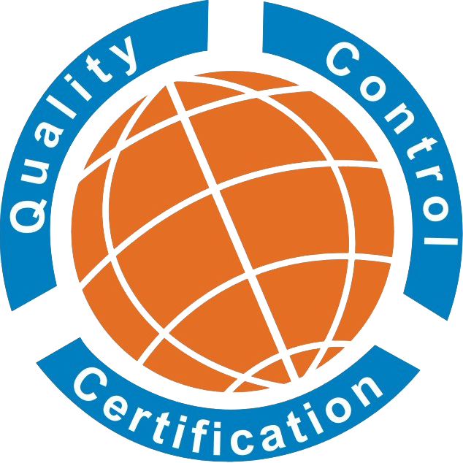 |  |  |  | Request for Proposal cum Application Form
1. Organization Details
Name of org. *:
Address 1 *:

Address 2:
(For more address attach separate Sheet)
Contact Person*: |  |  |  |  |  |  |  | Dept./Position:
Mob. /Tel.*: |  |  |  |  |  |  |  | Fax:
Website: |  |  |  |  |  |  |  | E-Mail*:
Require ISO Standard *:
ISO 9001 | ISO14001 |  |  | OH&S 45001 |  |  | ISO 22000 |  | ISO 27001 |  | ISO 20000-1 |  |  | Others….......................
Certification Program Required * |  | Initial Surveillance Recertification Transfer Scope Expansion
1.1 Existing Certification (If applicable)
ISO 9001 | ISO14001 |  |  | OH&S 45001 |  |  | ISO 22000 |  | ISO 27001 |  | ISO 20000-1 |  |  | Others..........................
Name of Certification Body: Certification No: Expiry Date:
If Other, please specify:
Scope applied *:
(i.e. Manufacture of abc)
2. Number of Employees (for multisite address attach separate Sheet) *
Activities |  |  | Shifts | Full Time | Part time |  |  | Performing Same type of Job |  |  |  | Temporary Unskilled workers |  |  | Effective No. of Employees
Management
Production Area
Quality Control/Technical
Administration
Other
Total No. of Employees
Operation for Weekend / weekly holiday:
3. Organization Activity
Legal Status of Organization (i.e. Proprietor/ Pvt. Ltd. Or Partnership) *:
Applicable Legal, statuary & regulatory act:
(i.e. Labour law)
Organization Key Process Area:
(i.e. purchase/store/production etc.)
Organization Products/Services:
(i.e. abc & xyz products etc.)
Any outsourcing process:
(i.e. printing etc.)
Is the organization part of some larger organization: if Yes (Please furnish the name) |  |  |  |  |  | Yes No
Language of document and record: |  |  |  |  |  | Language of audit:
4. Operation condition of Management System*
1. Has the documented management system been operated and maintained? |  |  |  |  |  |  |  |  |  |  |  |  | Yes No
- Approval/Implementation Date of Policy: ………….
- Approval/Implementation Date of Manual, Procedure and Instruction: …………….
2. Is the Internal Audit carried and the effectiveness of the audit is confirmed? |  |  |  |  |  |  |  |  |  |  |  |  | Yes No
- Date of Internal Audit: ………………
3. Is management review carried? |  |  |  |  |  |  |  |  |  |  |  |  | Yes / No
- Date of management review: ……………….
4. If operating multi-site, you  ① are same corporate?  ② are actually implementing same activity in control?  ③ have same CEO?  ④ are using same quality system and procedure?  * Please attach detail information about multi-site (Total site no./size and location of each site) |  |  |  |  |  |  |  |  |  |  |  |  | N/A Yes  Yes No  Yes No  Yes No  Yes No
4.1 This section Applicable for Environmental Management System ISO 14001:2015
How many Sites the company is Managing at the same time? ___________
Do you have Register of Significant Environment aspect? Yes No
Do you have An Environmental Management Manual? Yes No
Do you have An Internal Environmental Audit Programme? Yes No
4.2 This section Applicable for Occupational Health & Safety Management System ISO 45001:2018
Hazard’s Identified? Yes No
Detail any critical occupational health & safety risks identified? ______________________________________________
__________________________________________________________________________________________________

4.3 This section Applicable for Food Safety Management System ISO 22000:2018
Number of Sites to be Audited? Single Multiple
Have you implemented HACCP Principles? Yes No
Any seasonality issues? Yes No
If yes, give detail on separate sheet.
Total No of HACCP Studies (As per ISO/TS 22003:2013) ________
How many process lines are there in production _________
FSSAI License Registration No:
Any Prior Audits Conducted Yes No
If Yes, attach audit findings
Other Factors (Kindly Confirm No’s): -
Product Types=_____ ; Product Lines=_____ ; Product Development=_____ ; CCP=_____ ; OPRP=_____ ; Building Area=_____ ; Infrastructure=_____ ; In House Lab Testing=_____ ; Translator Requirements=_____ ;
4.4 This section Applicable for Information Security Management System ISO 27001:2013
- SOA Version No. _____ Date of implement: ____________________
- Any outsourced process (i.e. IT / Data Centre/Server) _____________
- Have you done Risk Assessment & Risk Treatment, If yes on which date ______

4. Business complexity [Please select type of complexity in your org. as per A, B, C, chose any no. from 1 or 2 or 3]

A. Type(s) of business and regulatory requirements | 1. Organization works in non-critical business sectors and non-regulated sectors;  2. Organization has customers in critical business sectors;  3. Organization works in critical business sectors.
B. Process and tasks | 1. Standard processes with standard and repetitive tasks; lots of persons doing work  under the organization’s control carrying out the same tasks; few products or services  2. Standard but non-repetitive processes, with high number of products or services  3. Complex processes, high number of products and services, many business units  included in the scope of certification (ISMS covers highly complex processes or relatively high number or unique activities).
C. Level of establishment of the MS | 1. ISMS is already well established and/or other management systems are in place  2. Some elements of other management systems are implemented, others not  3. No other management system implemented at all, the ISMS is new and not  established.

5. IT complexity [Please select type of complexity in your org. as per A, B, C, chose any no. from 1 or 2 or 3]

A. IT infrastructure complexity | 1. Few or highly standardized IT platforms, servers, operating systems, databases,  networks, etc.  2. Several different IT platforms, servers, operating systems, databases, networks  3. Many different IT platforms, servers, operating systems, databases, networks.
B. Dependency on outsourcing and suppliers, including cloud services: | 1. Little or no dependency on outsourcing or suppliers  2. Some dependency on outsourcing or suppliers, related to some but not all  important business activities  3. High dependency on outsourcing or suppliers, large impact on important business  activities.
C. Information System development: | 1. None or a very limited in-house system/application development  2. Some in-house or outsourced system/application development for some important  business purposes  3. Extensive in-house or outsourced system/application development for important  business purposes.

6. Confirmation of access to organizational records
1. Agreed to share all the ISMS records or information about design and effectiveness of controls for review by audit team.
2. Not agreed to share all the ISMS records or information about design and effectiveness of controls for review by audit team, because it contains confidential or sensitive information.
If you are “not agreed”, please mention the information which cannot be shared in during the audit:
___________________________________________________________________________
___________________________________________________________________________

4.5 This section Applicable for Information Technology - Service Management System requirements ISO 20000-1:2018
1. Few or simple or highly standardized IT platforms, 1 or 2 servers, operating system, database, networks
2. Several different IT platforms, 3-5 servers, operating system, database, networks
3. Many different IT platforms, more than 6 servers, operating system, database, networks

Is there any ITSMS Documentation & records which cannot be made available for review by the audit team because they contain confidential or sensitive information and to provide the corresponding justification.
Kindly provide list of such information: ……………………………………………………………………………………………………………………………
4.6 This Section is applicable for Medical Device Quality Management System ISO 13485:2016
1. Number of Sites to be Audited? Single Multiple
2. Any Outsourced process:
3. Critical activity:
4.7 This section is applicable for Learning Services Management System
Number of Sites to be Audited? Single Multiple
Methodology of Learning is Described Yes No
Any conflicts regarding Learning Services Management system Yes No
Outsourced process:
5. Details of the consultancy firm/consultant has taken consultancy for ISO 9001/ISO 14001/ISO 45001/ISO 22000/ISO 27001/ISO 20000-1 or other standard process in organization:
- Consulting Company Name: .....................................................................................................................................
- Write the name of consultant: ……………................................................................assisted for establishment of system.
6. Other details of Organization
……………………………………………………………………………………………………………………………………………………………………………………..
…………………………………………………………………………………………………………………………………………………………………………………….
…………………………………………………………………………………………………………………………………………………………………………………….
Note: if required, please attach relevant supporting document(s)
DECLARATION: The above information is true to the best of my knowledge and belief and I am authorized to provide such information on behalf of the above said organization, we request an estimate/Quotation as above mention.

Person Name (who Filled Application): .........…………....…
This section is for Office (QCC) Use only.

Acceptance, Ref. No. _____________ Not Acceptance

Supplement information is needed: _________________________________________________________________

Note: “*” fields are mandatory.
Annexure -01 (For Multi-site)
Site Country Name:
Name of Site*:
Address 1 *:

Contact Person*: |  |  |  |  | Dept./Position:
Mob. /Tel.*: |  |  |  |  | Fax:
Website: |  |  |  |  | E-Mail*:
Require ISO Standard *:
Site Scope/Activity:
(i.e., Manufacture of abc)
2. Number of Employees:
Activities |  | Shifts | Full Time | Part time | Performing Same type of Job |  | Temporary Unskilled workers | Effective No. of Employees, Filled by B4Q
Management
Production Area
Quality Control/Technical
Administration
Other
Total No. of Employees
Operation for Weekend / weekly holiday:

In case, if you have more site’s, kindly fill this annexure per site.

